# Name:Abdallah Mohamed Abdelnaby Abdo

**E.mail:** abdallah190021@feng.bu. edu.eg

**B.N:**500

**Tobic:** programming languages

**Githup:**

**Githup Page:**

**-Application Brief:**

A programming language is a language we use to communicate with a computer and give it a set of tasks to do. Programming languages can be divided into two main groups: high-level programming languages and low-level programming languages. High-level programming languages are easier to code in. The key words and the syntax is closer to how we think and speak which makes it easier to write. Despite them being simple for us, they are quite complicated to computers because they are far from the languages that computers understand, called machine language. When a program is written in a high-level programming language, for it to be understood by the computer, it need to be compiled into machine language. When we say the term programming language, we mostly mean high-level programming languages such as Java, Ruby or Python. Low-level programming languages on the other hand are more difficult to code in. They are much closer to actual machine code than high-level programming languages are and require a much deeper understanding of how machines work and machine language to make good use of them. Some of the advantages of using low-level programming languages is that the program can be run much faster. The code which was written needs to be processed much less and is understood by the computer much faster because the compilation process that any high-level programming language has to go through is much shorter for low-level languages. Low-level programming languages also run with a very minimal memory footprint. The main low-level programming languages we can talk about are assembly language and machine language. There are also languages such as C and C++ which are considered middle-level programming languages. Despite the abstraction that is done to the code for it to remain understandable and easy to use for programmers, this has little to no cost when it comes to performance and efficiency which high level programming languages affects greatly.

**-screen shots:**

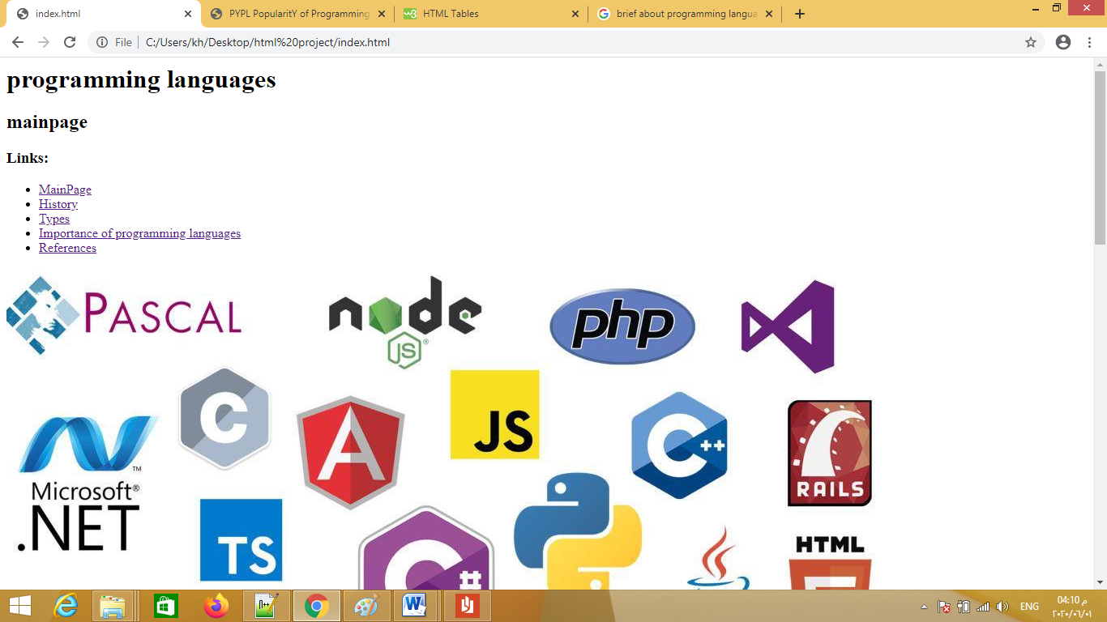

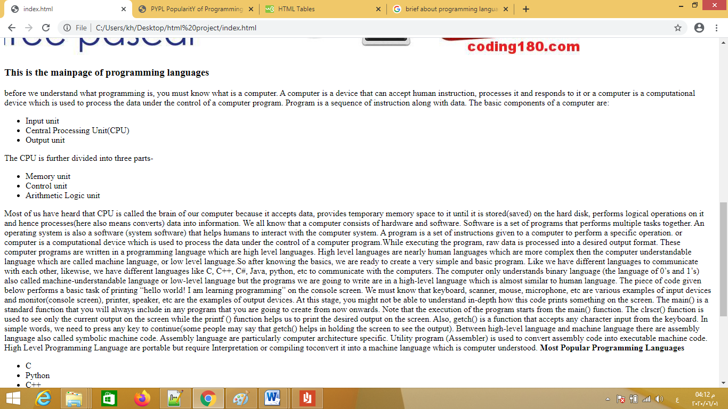

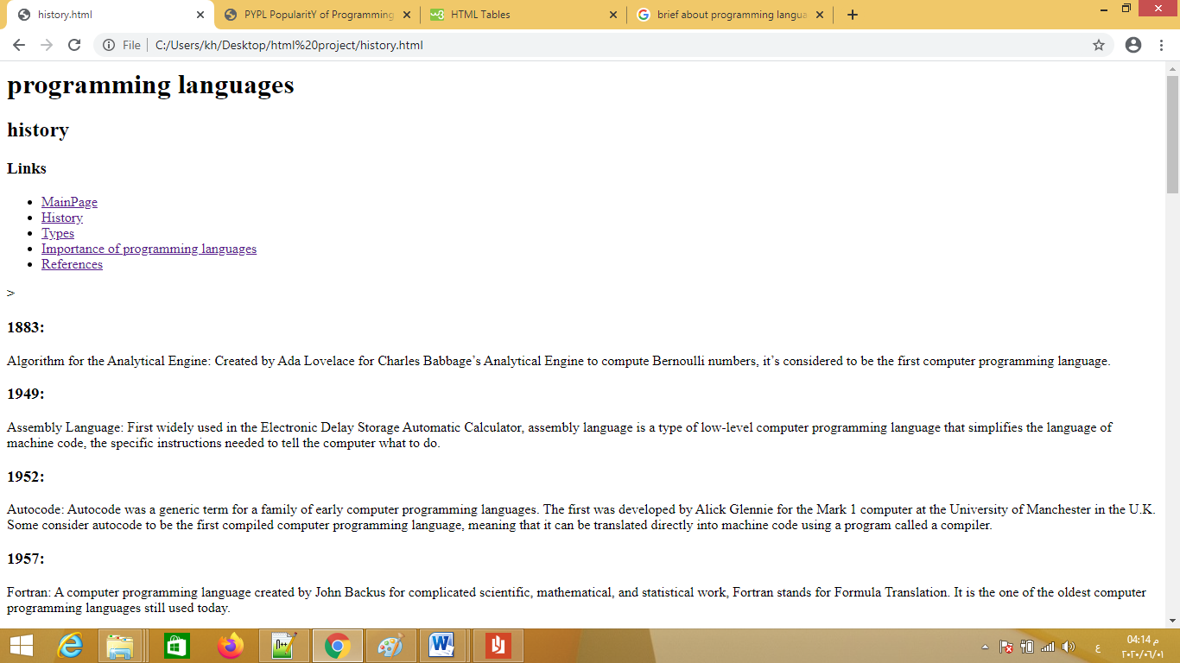

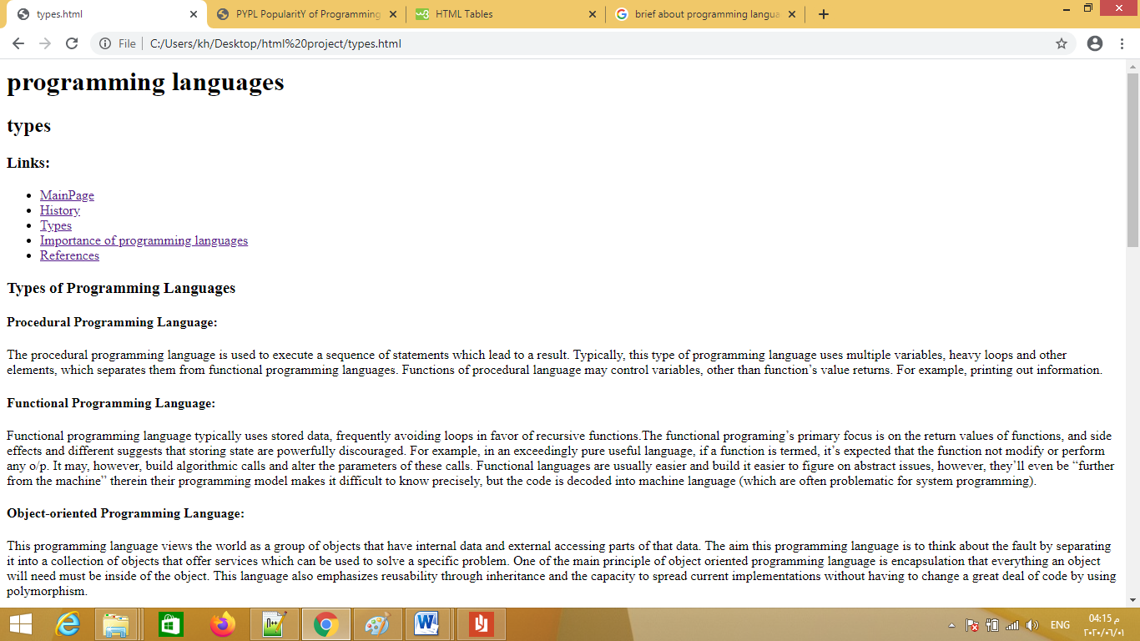

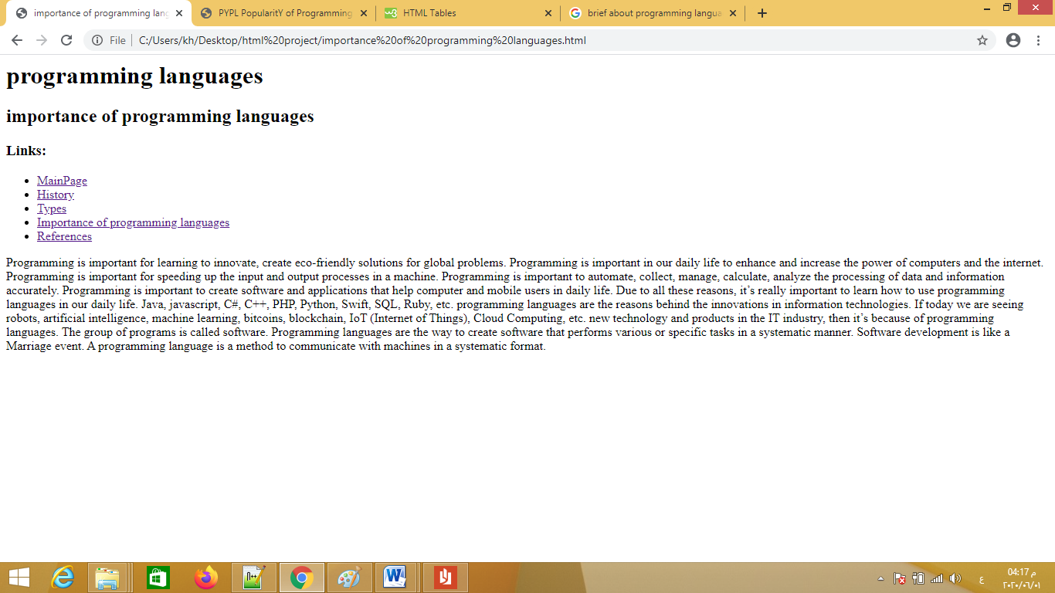

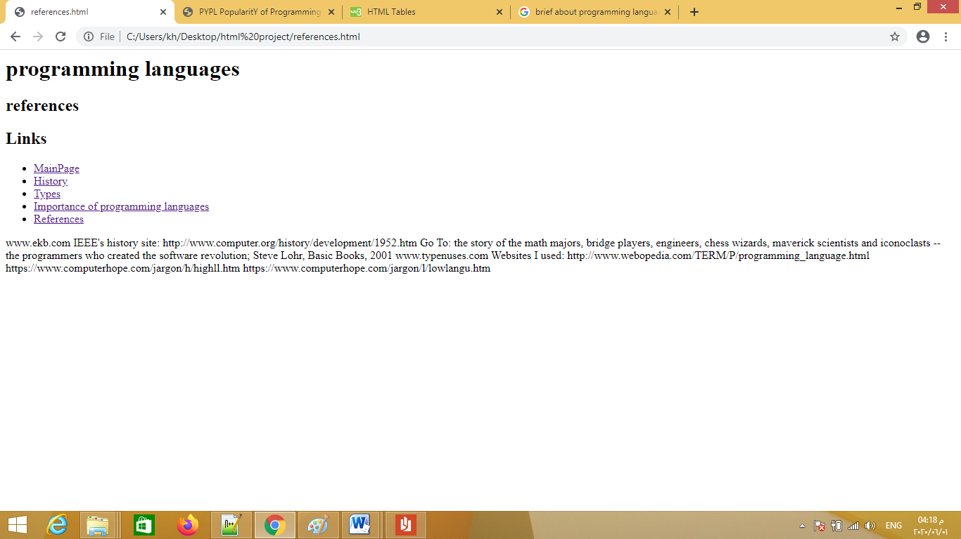

**-Source**  **code:**

